OMG Release Notes
Intermx UI Product & API Services Production release from 05.04.2022

Now Available in Production
Vendor Contract Layout Formatting Requests Implemented
What We Did
Intermx implemented the following formatting requests on the Vendor Contract layout:
- The Impressions column no longer appears
- The Spot Length / Qty column replaces the Spot Size / Rotation column.
Figure Vendor Contract Layout with Updated Columns
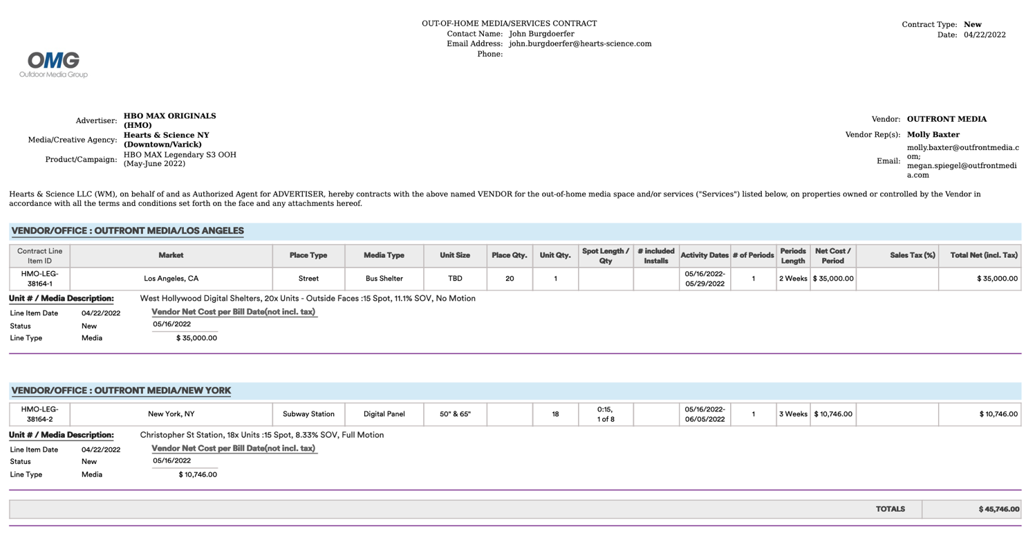
JIRA Ticket:
- IMXDEV-134

Updated Page Break Logic Now Available in “Billing & Invoice” Reports
What We Did
Previously, OMG Reports did not have logical page breaks to align with the best presentation of the data. In particular, the Invoice layouts needed to reflect the intended page breaks for distribution to clients.
The Details
Intermx updated the page break logic to ensure that values on reports appear correctly. In this release, the following reports were updated:
- Billing & Invoices => Client Gross Invoice
- Billing & Invoices => Separate Media Invoice
- Billing & Invoices => Separate Fee Invoice
Note: Additional page break corrections will be reflected for remaining reports in the next release.
JIRA Tickets:
- IMXDEV-120
- IMXDEV-121
- IMXDEV-99

