OMG Release Notes
Motionworks UI Product & API Services Production release from 05.16.2022

Now Available in Production

Updated Columns Now Available on Line Item Table
What We Did
The following columns are now available on the line item table for contracts:
- Vendor Unit ID
- Vendor Spot ID
- Geopath Spot ID
Figure Updated Columns on Line Item Table for Contracts
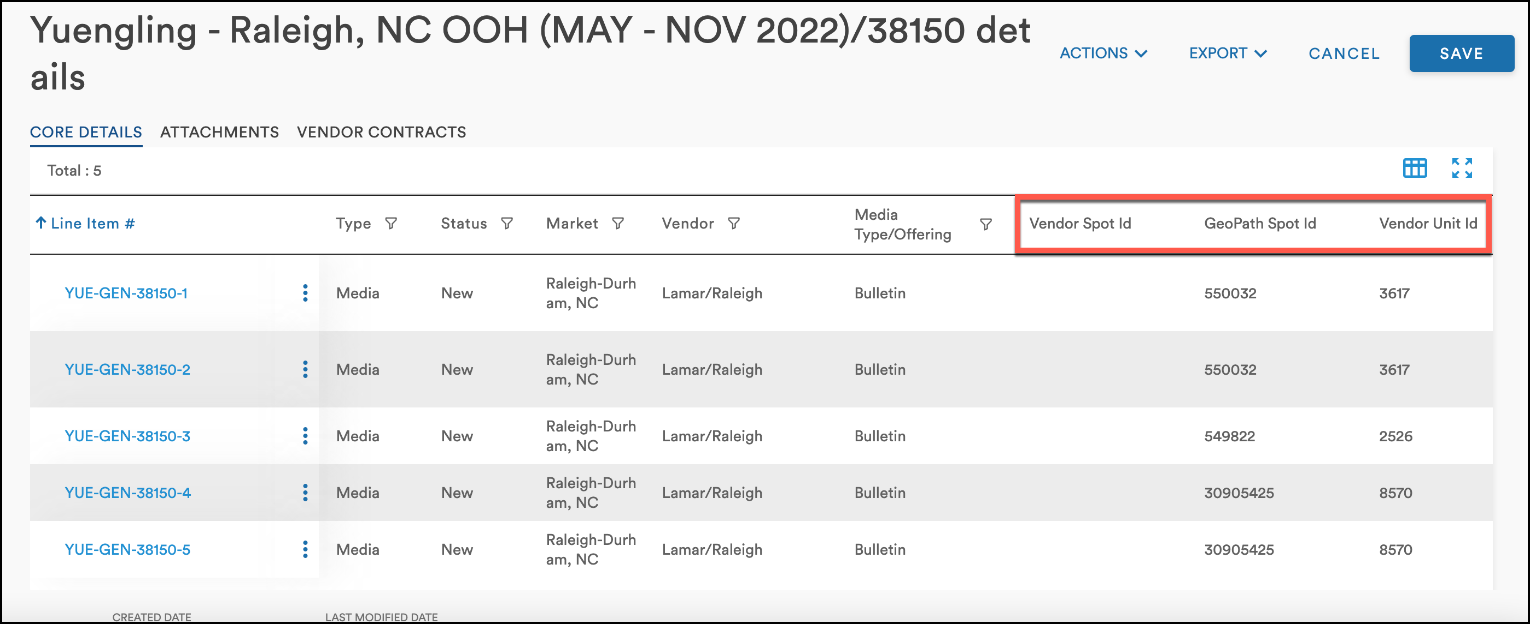
JIRA Ticket:
- IMXDEV-136
Updated Functionality for Contracts
What We Did
Users can now delete any line items that do not contain exported insertion orders (IOs). Previously, if any IO on any line item of a contract was exported, users were unable to delete any line items on the contract.
JIRA Ticket:
- IMXDEV-296

