OMG Release Notes
Motionworks UI Product & API Services Production release from 05.23.2022

Now Available in Production

Bug Fixes
Due to an error, users were unable to generate Vendor Contracts if the Contract Name contained special characters. The system now generates Vendor Contract views with the Contract ID in lieu of the Contract Name, and users can now create Vendor Contracts with special characters.
  - JIRA Ticket: IMXDEV-327

An incorrectly formatted file prevented users from being able to export Contacts from Records Management to Excel. Motionworks corrected this issue and users can now successfully open the file in Excel.
Figure Incorrectly Formatted File Alert
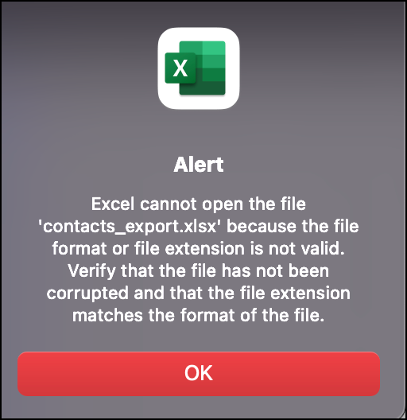
  - JIRA Ticket: IMXDEV-273

When users searched for specific terms on job line items, the exported CSV file included all job line items rather than just the found record set. This has been corrected and the exported CSV file only reflects what the user included in their filter/search results.
  - JIRA Ticket: IMXUIPRD-4832

